E-Learning Module: Logical Fallacies
Originally created for online writing courses at the University of Utah.

Part I: Why do fallacies matter?

As human beings, we like to be right. This isn’t a bad tendency, especially when making an argument. Wanting to be right helps us pick out strong pieces of evidence, design our arguments logically, and use persuasive language to help convince others. But it does mean that our minds come with a design flaw otherwise known as the confirmation bias.

Psychology Today explains that the “confirmation bias” is what happens “when people would like a certain/idea concept to be true, they end up believing to be true.” Let’s say you start noticing a lot of orange cars around town when you’re shopping. You say to your friend “it seems like orange cars are much more popular now.” Oddly enough, you and your friend begin seeing every single orange car that passes by. You’re definitely noticing more orange cars than before, and you’re definitely right that there are more orange cars around.

The confirmation bias can be insidious. It's what leads us to see every new orange car we see as confirmation of our claim. Confirmation biases can lead us to ignore valuable new evidence, to reject credible sources, or to miss where the arguments we've built falter logically.

Part II: Types of Fallacies

There are two types of fallacies, oversimplifying and misdirection. Check out the images below for examples of each.

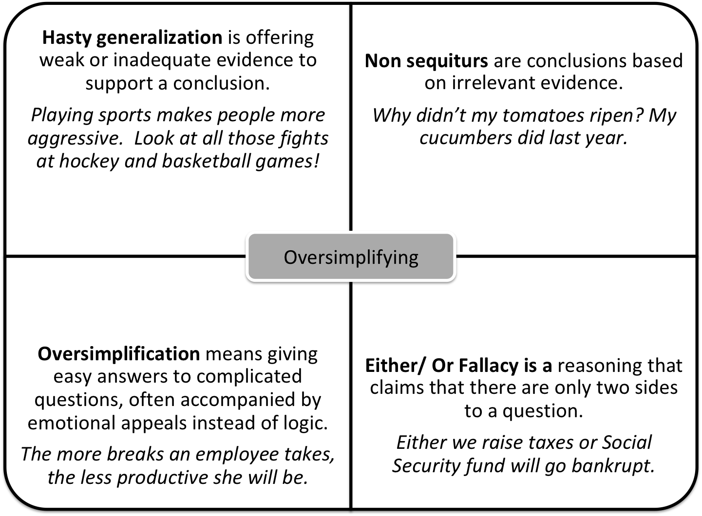

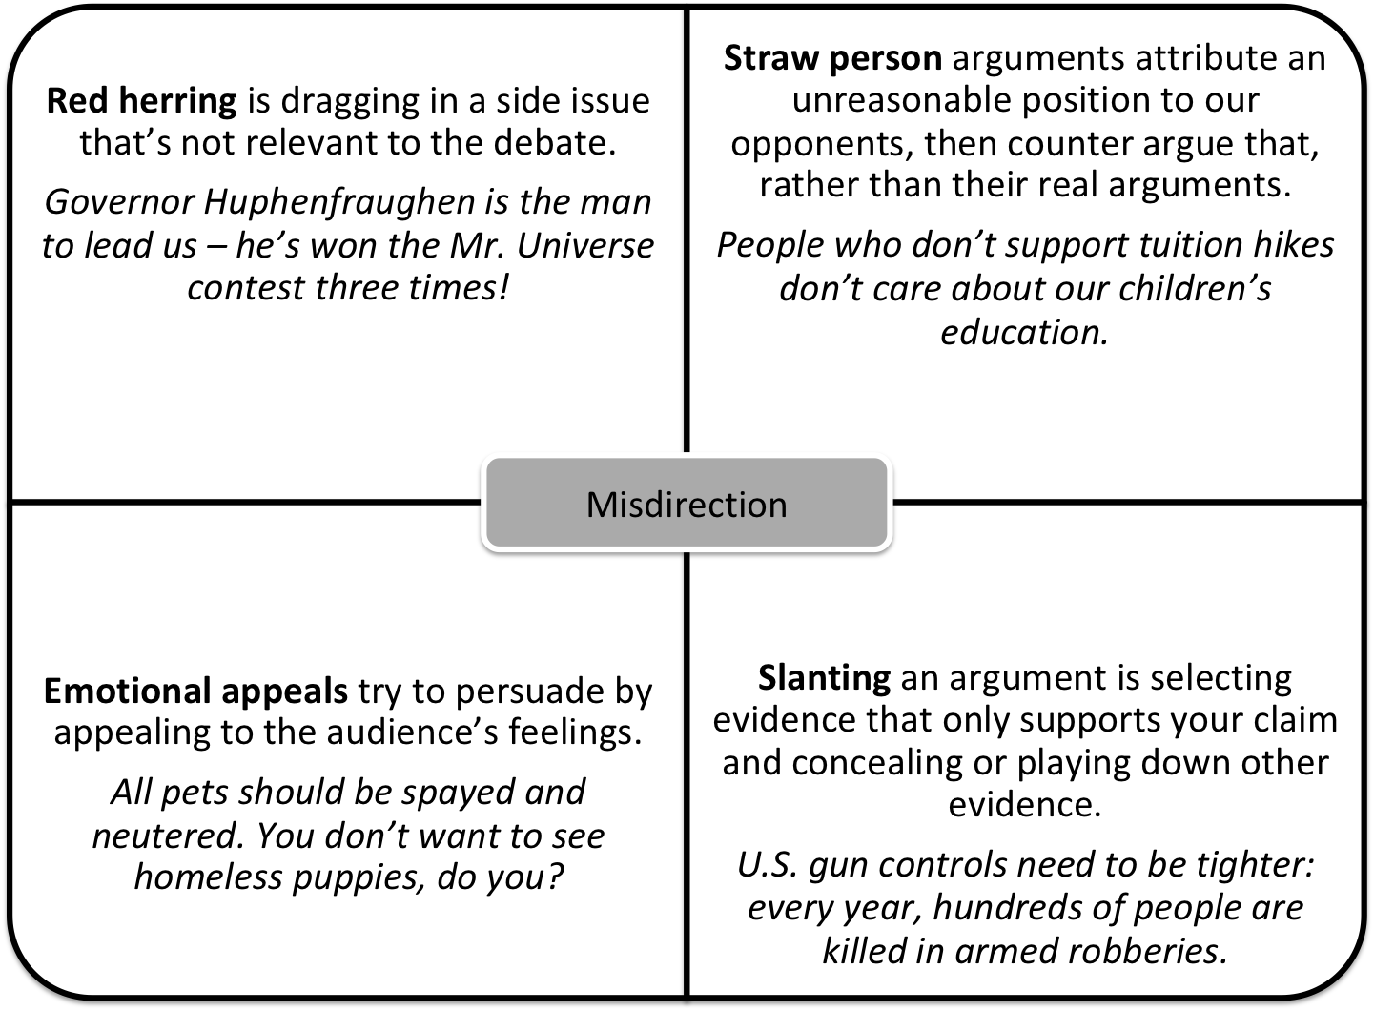

**Source text from Open 2010 by Jay Jordan at the University of Utah.

Review these and other fallacy examples in Open 2010, chapter 5, and then complete the quiz “Identifying Fallacies.”

Quiz: Identify the fallacy in the sentence.

1) Star Wars is just like every other science fiction film out there: it has aliens, spaceships, and laser guns.
- no fallacy
- ad hominem
- slippery slope
- red herring
- hasty generalization

Answer: e. hasty generalization
This may look credible, but the evidence provided is scanty and vague.

2) If Star Wars can’t present a diverse cast of characters, then there’s no hope for the rest of Hollywood.
- no fallacy
- ad hominem
- slippery slope
- red herring
- slanting

Answer: c. slippery slope
There’s no reason why Star Wars should speak for all blockbuster movies, much less all of the film industry.

3) Star Wars and Star Trek are essentially the same film in different universes—after all, the similarity can be seen in their names!
- no fallacy
- false causality
- false analogy
- straw person
- ad hominen

Answer: c. false analogy
The two movies share some basic similarities, but not to the point that the fallacy claims.

4) Star Wars is one of the greatest blockbuster films of all time. 8 million people went to see Revenge of the Sith on the release day!

- no fallacy
- bandwagon
- oversimplification
- red herring
- hasty generalization

Answer: b. bandwagon
8 million people could all be wrong!

5) Princess Leia is one of the earliest feminist role models in science fiction. Just look at Carrie Fisher’s writing career!
- no fallacy
- false causality
- slanted phrasing
- red herring
- emotional appeal

Answer: d. red herring
Carrie Fisher may have played Princess Leia, but her writing career has nothing to do with the character.

6) The new Star Wars movies have been critiqued for their lack of originality, but those who disliked them are simply overly attached to the first trilogy.
- no fallacy
- straw person
- bandwagon
- false argument to ignorance
- hasty generalization

Answer: b. straw person
Ignores the actual reasoning and substitutes a distorted version.

Part III: Logical Fallacies in A Claim

Now, let’s take a look at a sample argumentative claim.

Claim: Disabled characters should be played by disabled actors. This will not only increase representation, but encourage diversity in the depiction of disability.

So far, so good! But let’s take a look at some possible logical fallacies that I might encounter when arguing my claim.

- Begging the Question: Disabled characters should be played by disabled actors. After all, disabled actors are the ones who can play them the best.

Why? I don't offer any evidence as to why disabled actors should be cast to play disabled characters beyond a simple "they should." I need to add more evidence and discuss representation, credibility, and the history of disability rights.

- Straw Person: Anyone against casting disabled actors will have no problem attacking the Americans with Disabilities Act.

Why? I’m making a leap in logic here from assuming that anyone who is in favor of open casting is against accessible parking spaces and bathrooms. This isn’t fair to my opponent, and it doesn’t make sense.

- Non sequitur: Many non-disabled actors have been critically praised for playing disabled characters, such as Daniel Day-Lewis in My Left Foot and Eddie Redmayne is Theory of Everything. However, d/Deaf actress Marlee Matlin won the Tony Award for her performance in Children of a Lesser God.

Why? Although these examples are all regarding critical praise, the first two examples have nothing to do with the third.

Activity: Try to think of some logical fallacies that your own argument might encounter. What might be some dangerous logic for you to run into?

